Boo-boo the Bean Bag Adventures By Eva Stanbridge
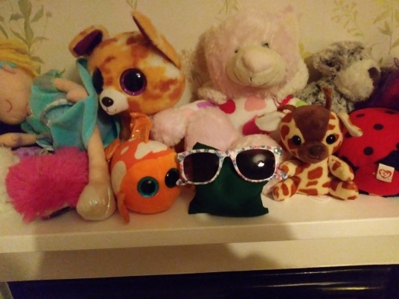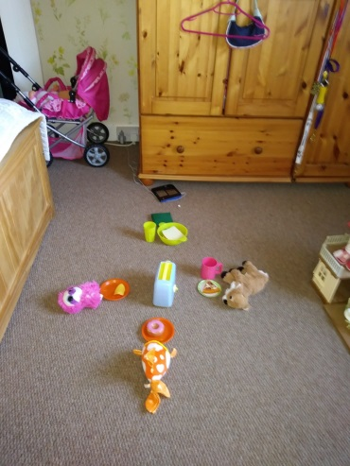
On Saturday morning Barry made friends in my bedroom with my soft toys. I counted and arranged them in order of size. I made breakfast for Barry and his friends, using my picnic set.
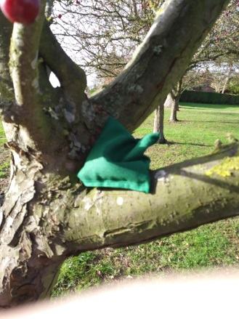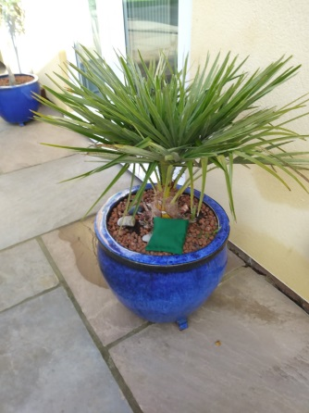
My brother and I played hide and seek with Barry in the garden. He hid him in the trees, bushes and plants.
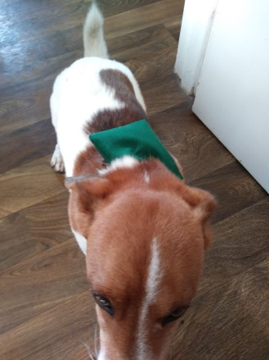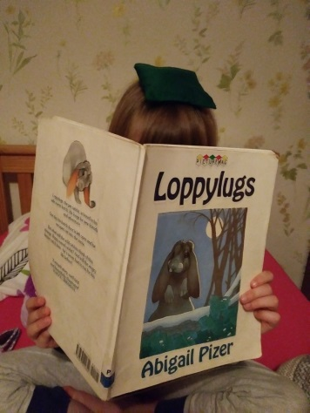
After lunch Barry came for a walk with me and my family, he had a ride on Freddie’s back. When we got home I read a book to him whilst he balanced on my head.

