Swimming festival
The people that went were Pranavi, Tom, Daniel, Caitlin, Lucca, Luca, Max, Georgina, Tayla, Lily, Layla.
From Pranavi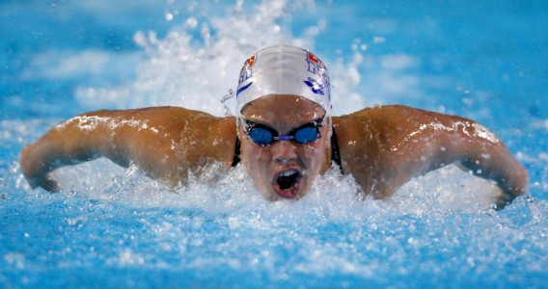
We tried really hard and we showed our values like respect, Sportsmanship, cooperation.
We did underwater diving, relay and much more.
The strokes that we did was front crawl back stroke breast stroke butterfly and dolphin.

