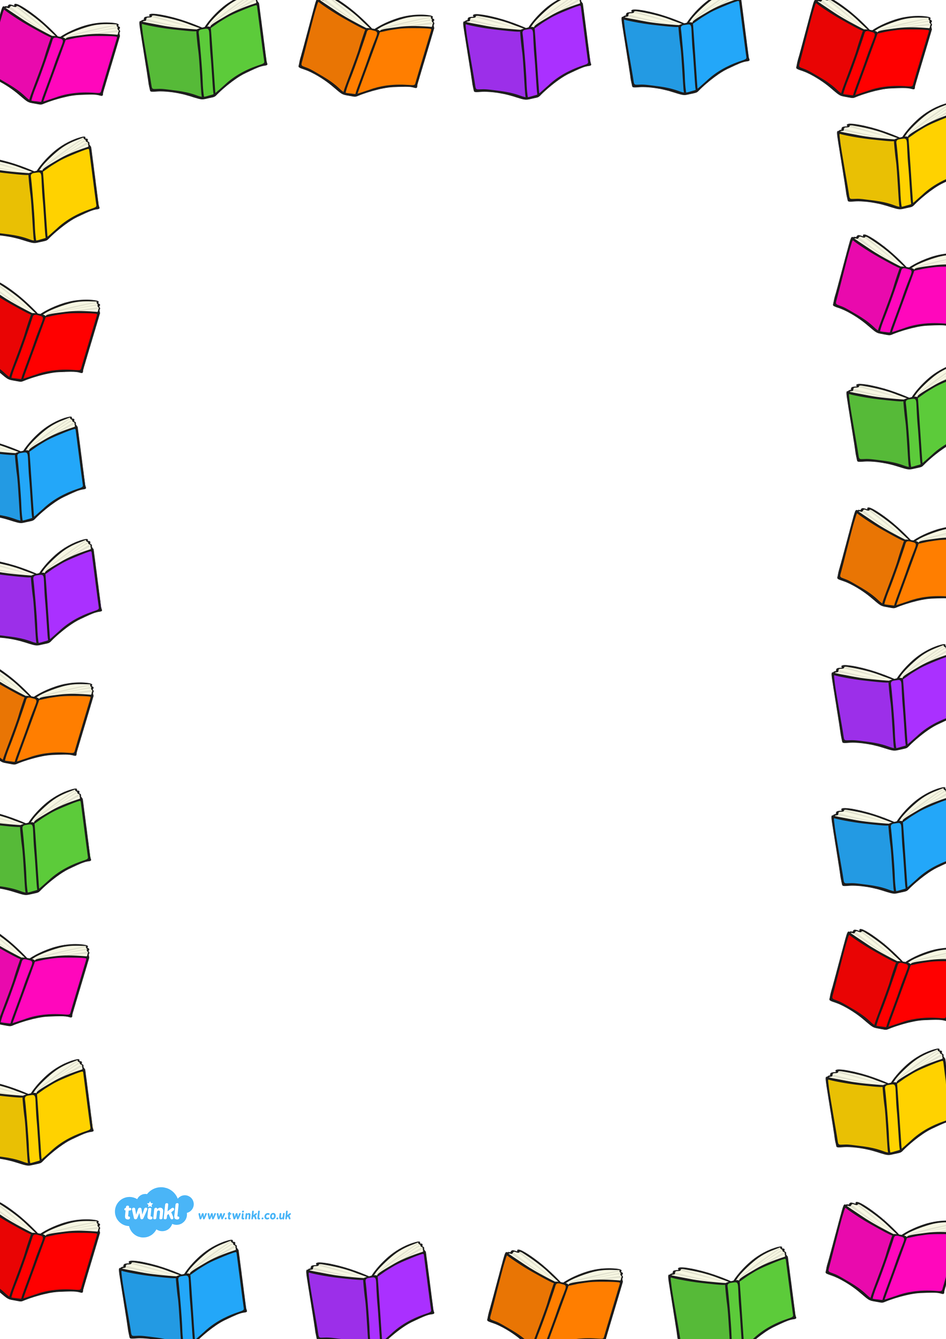
Reading at Home

Choose the questions which apply to the text and help the child to go back and look for the answer if they are unsure.

What is the title of the book?
What type of book is this fiction or non-fiction?
What do you think is going to happen in this story?
Is this a fairy story? How do you know?
Where is the story set?
Have you ever done that? Did you enjoy it?
What does this word mean?
Why is the character doing that?
What has happened in the story so far?
How is the character feeling? Why do they feel that way?
How would you feel is you were that character?
What do you think is going to happen next? Why?
Who is your favourite character? Why?
Is there a hidden message in the story? What is it?
Can you retell the story in your own words?
Do you like how the story ended?
Can you think of another way the book could have ended?
Did you enjoy the story? Would you recommend this story to someone else?

